TURIST PLACES:

Machu Picchu

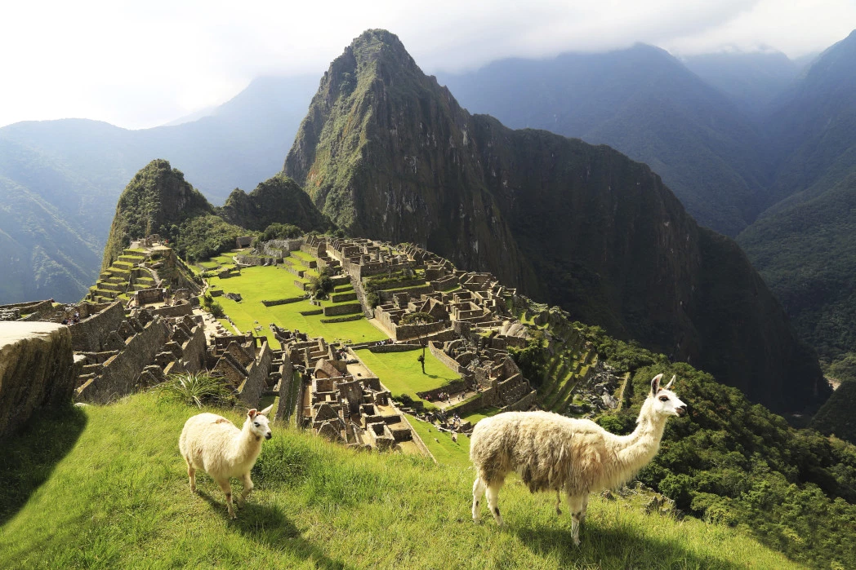

Tourists are increasingly interested in South America, as they seek less known places in the world. Machu Picchu is one of the most recognizable icons of the continent and the tourism figures reflect it. After receiving 1 million visitors in 2016, tourism officials decided to reduce the input allocation in efforts to save these ruins from falling apart.

Mauricio and Fernando